**SHIMONI DEMONSTRATION SCHOOL-KIRA**

**MID TERM II EXAMINATIONS, 2024**

**P.1 LITERACY**

Name: _____________________________________________________________

***SECTION A***

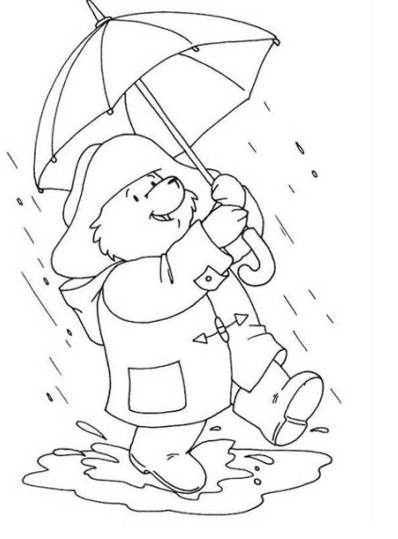1. Name the animal that guards people’s homes.

____________________________________________________________

2. Who flies an aeroplane? ______________________________**(Pilot teacher)**

3. Which body part is used for seeing?

___________________________________________________________

4. Name this type of weather. **(Sunny weather, Rainy weather)**



_________________________________________________

5. Write one thing found at home.

____________________________________________________________

6. Who heads a family?

____________________________________________________________

7. ________________________________ is moving air.

8. Who treats sick people?

____________________________________ **(teacher doctor)**

9. Write one activity done at school.

______________________________________**(digging , playing)**

10. Name the clouds that bring rainfall.

____________________________ clouds. **(Nimbus Cumulus)**

11. **Draw this garden tool.**

|  |
| --- |
|  |
| panga |

12. Who cooks food at home?

____________________________________________________________

13. A _____________________________ gives us milk.

14. Write down one thing we use to clean our body.

____________________________________________________________

15. Name any one common accident.

____________________________________________________________

16. Mention any one element of weather. **(food, sunshine)**

____________________________________________________________

17. Name this dangerous object.

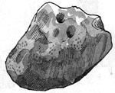

_______________________________________________

18. Write one person found at school.

____________________________________________________________

19. We get _______________________________ from rain.

20. A _______________________________________ keeps law and order.

**(policeman carpenter)**

***SECTION B.***

21. **Circle the childhood disease.**

Measles malaria tetanus flue

polio cholera tuberculosis cough

22. **Name these types of weather.**

|  |  |  |  |
| --- | --- | --- | --- |
|  |  |  |  |
|  |  |  |  |

 **(rainy windy sunny cloudy)**

23. **Match animals to their young ones.**

dog calf

cow lamb

goat puppy

sheep kid

24. **Draw these dangerous objects.**

|  |  |  |  |
| --- | --- | --- | --- |
|  |  |  |  |
| razorblade | needle | snake | fire |

 25. (a) Write down two things found at school.

(i) ________________________________(ii) __________________________________

**(b) Complete correctly.**

A ____________________________ teaches pupils. **(gate keeper, teacher)**

A ___________________________ opens and closes the gate.

26. (a) Write down any two uses of water.

(i) _________________________________________________________

(ii) _________________________________________________________

(b) Name two places where we get water.

(i) ________________________________(ii) __________________________________

27. Name these activities done in different season.

|  |  |  |  |
| --- | --- | --- | --- |
|  |  |  |  |
|  |  |  |  |

**(sun drying harvesting weeding watering)**

**28. Match people in our community to their work.**

Carpenter grows crops and keeps animals

Farmer treats sick people

Priest makes furniture

Doctor preaches the word of God

29. (a) _________________________________ are animals kept at home.

(b) Give three examples of domestic animals.

(i) _____________________________(ii) ________________________________

(iii) ______________________________

30. (a) Write down any two members of a nuclear family.

(i) ________________________________(ii) _________________________________

(b) Draw these family members.

|  |  |
| --- | --- |
|  |  |
| grand mother | grand father |

31. **Match the animal sounds.**

Dog bleats

Goat mews

Snake barks

Cat hisses

32. **Draw these garden tools.**

|  |  |  |  |
| --- | --- | --- | --- |
|  |  |  |  |
| hoe | basket | knife | rake |

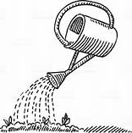33. (a) Name the two types of seasons.

(i) ________________________________(ii) __________________________________

(b) Name the main natural source of heat and light.

___________________________________________________________

(c) Give one use of the sun.

____________________________________________________________

34. (a) A _________________________________________ is a group of people living and working together. **(home , community)**

(b) Name any two important places in our community.

(i) _________________________________________________________

(ii) _________________________________________________________

(c) **Draw this important place.**

|  |
| --- |
|  |
| **church** |

35. (a) Give one use of plants.

Plants give us _______________________________________________.

(**food water medicine baby)**

(b) Name these main parts of a plant.

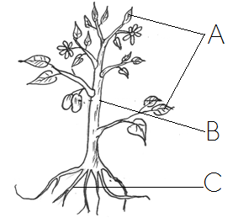

A __________________________________

B ___________________________________

C __________________________________

**(leaves flowers stem fruit root)**

***\*\*\*\*GOD BLESS\*\*\*\*\****